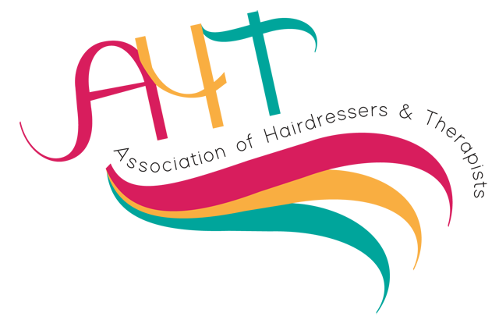

A National Network for Hairdressing & Beauty Professionals

Membership Application 2022-2023

Current membership for 1st October 2022 – 30th September 2023 – costs £30.00 per year

Visit us on social media
https:www.aht-uk.com, https://twitter.com/aht_of, https://www.facebook.com/groups/243231353057926

Complete below and return with payment of £30.00p made payable to AHT or copy of standing order to:

Jonathan Putt, National Treasurer, 9 Tamar Close, Whitefield, Manchester, M45 8SJ

Members wishing to pay by standing order; please send an order to the above address or by email to jputtahttreasurer@gmail.com

Name: | Occupation | ✅ | Identify Specialism | ✅
Home Address: | Qualified Teacher |  | Hairdresser
Town/City: | Professional Trainer |  | Beauty Therapist
Postcode: | Trained Assessor |  | Nail Technician
Telephone: | Business Owner |  | Barber
College/Centre: | Academy Personel |  | Make up Artist
Email: | Industry Retail Establishment |  | Hair Extension Specialist
Alternative email: | Retired |  | Wig Maker
 | In Training /Student |  | Other-Please state
Required Field: I agree for membership, updates and information to be emailed to me. ロ | Manufacturer

For more information contact:
National Treasurer : Jonathan Putt
Email: jputtahttreasurer@gmail.com

